|  |  |
| --- | --- |
| **[http://staff.pls.lib.ok.us/new/public/thumbnails/smwtvert_jpg.jpg](http://staff.pls.lib.ok.us/new/public/pages/smwtvert_jpg.htm)** | Quadcopter Gotchas  Norman Public Library  Computer Training Center |

# Assembly

* 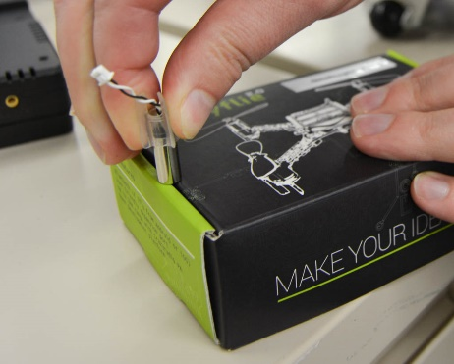It can be hard to get the motors pushed into the feet: **do not** push the motor shaft against a hard surface, you will destroy the motor! Instead, use the slot in the top of the box to apply pressure to the motor housing without putting pressure on the shaft.
* Make sure the kids notice the two different types of rotors (clockwise and counter-clockwise) and place them on the appropriate motor.
* Have them double-check to ensure the rotors are on right-side up, putting them on upside down is a common mistake.

# Flying

* Only nine of the Crazyradio USB dongles work: the broken one is labelled.
* Remember to right-click on the CrazyfliePLS.py script and choose “Edit in Idle…”
* Changing the quadcopter number in the code to match the number on their quadcopter is a critical first step!
* Always power the quadcopters off between runs. When powering on, make sure the quadcopter is on a stationary, flat, level surface before tapping the power button.
* Sometimes the interference causes the radio to fail to connect to the quadcopter. Just run it again, interference only matters during a very short window while it’s trying to connect at the beginning of the code and a second try almost always resolves the problem.